2277 – Capstone – Python for Generative AI

Module 02: Python Basic Tutorials

Elements of Python

- Variables and Reserved words
- Valid syntax patterns
- Constructing a program for a purpose

Python Scripts

Interactive
- Python is good for experiments and programs of 3-4 lines long
- You type directly to Python one line at a time and it responds

Python scripts
- A sequence of statements (lines) into a file using a text editor with more commands, conditions, loops etc. (abc.py)

Python notebooks
- An interactive, web-based environment where you can write and execute Python code in cells.(xyx.ipynb)
- Notebooks allow mixing of code, markdown (text), and visual outputs like plots, making them great for documentation and data analysis.

Program Steps and Program Flow

• Like a recipe or installation instructions, a program is a sequence of steps to be done in sequence
• Some steps are conditional
• Sometimes a step or group of steps are to be repeated
• Sometimes we store a set of steps to be used over and over as needed several places throughout the program

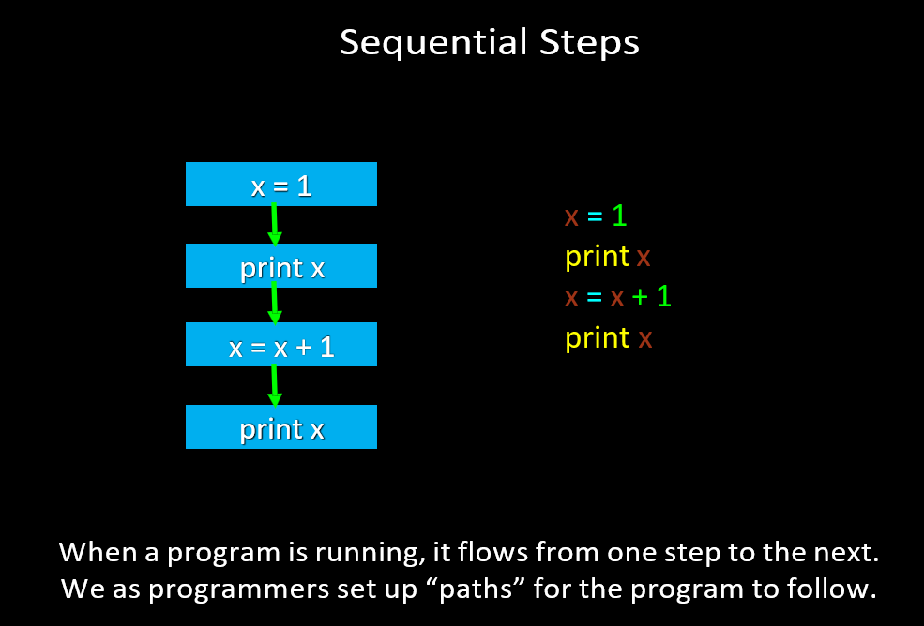

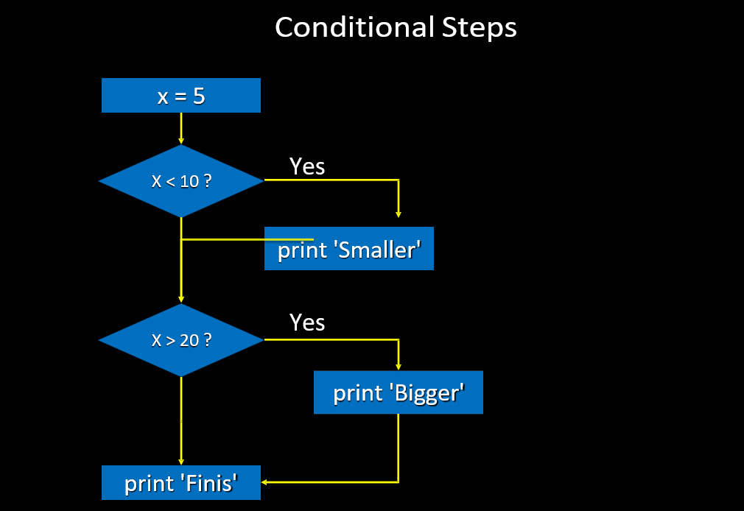

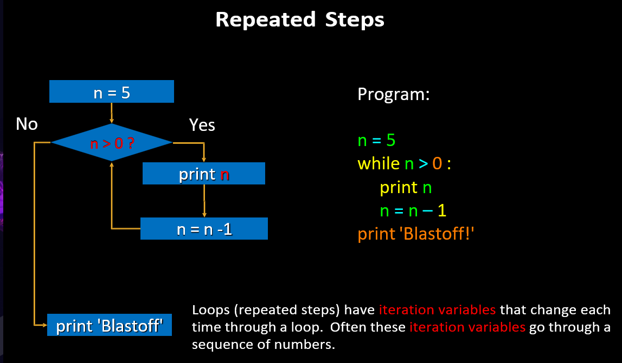
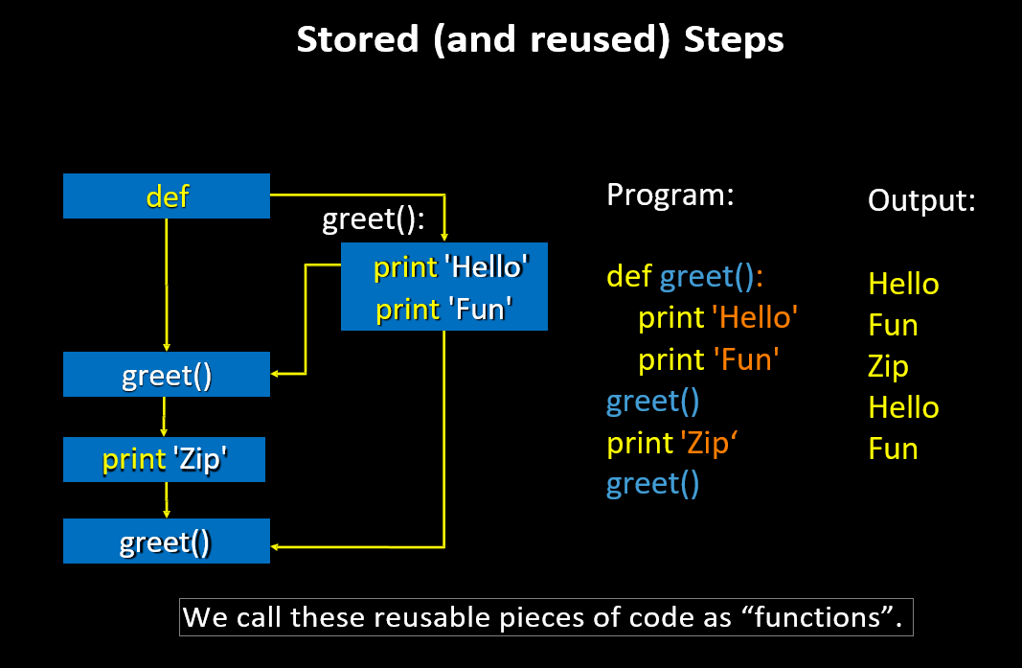

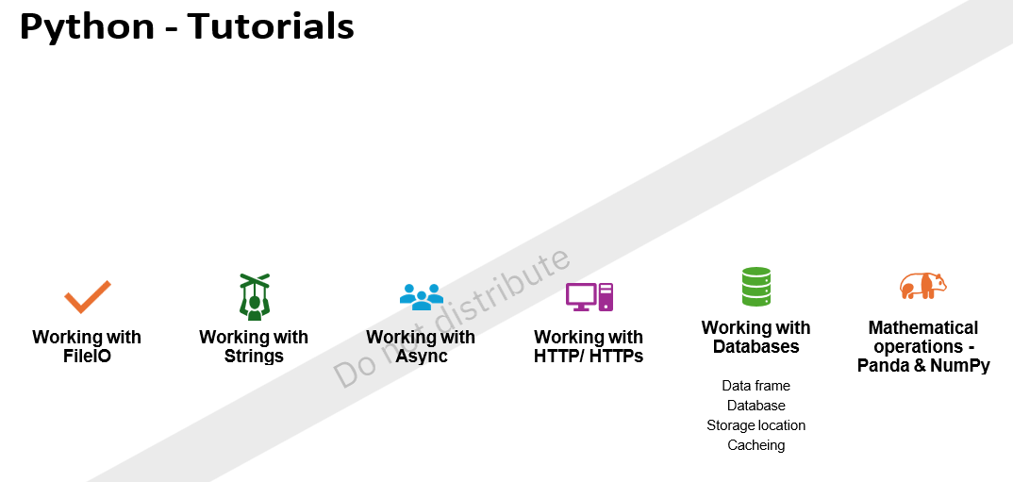

Python - Tutorials
1. Working with FileIO - Read and write files to store and retrieve maintenance logs, equipment data, and predictive maintenance models.
2. Working with Strings - Process and manipulate strings to handle equipment
identifiers, log messages, and sensor data entries.
3. Working with Async - Perform asynchronous tasks to handle real-time data streaming from sensors and concurrent processing
4. Working with HTTP/ HTTPs - Communicate with external APIs to fetch weather data, which might affect equipment performance, and send alerts
5. Working with Databases - Store and retrieve equipment data, maintenance
schedules, and prediction results in a database.
a) Data frame
b) Database
c) Storage location
d) Caching
e) Mathematical operations - Panda & NumPy - perform mathematical operations on sensor data to analyze trends and make predictions.

